THEORY QUESTIONS
1.
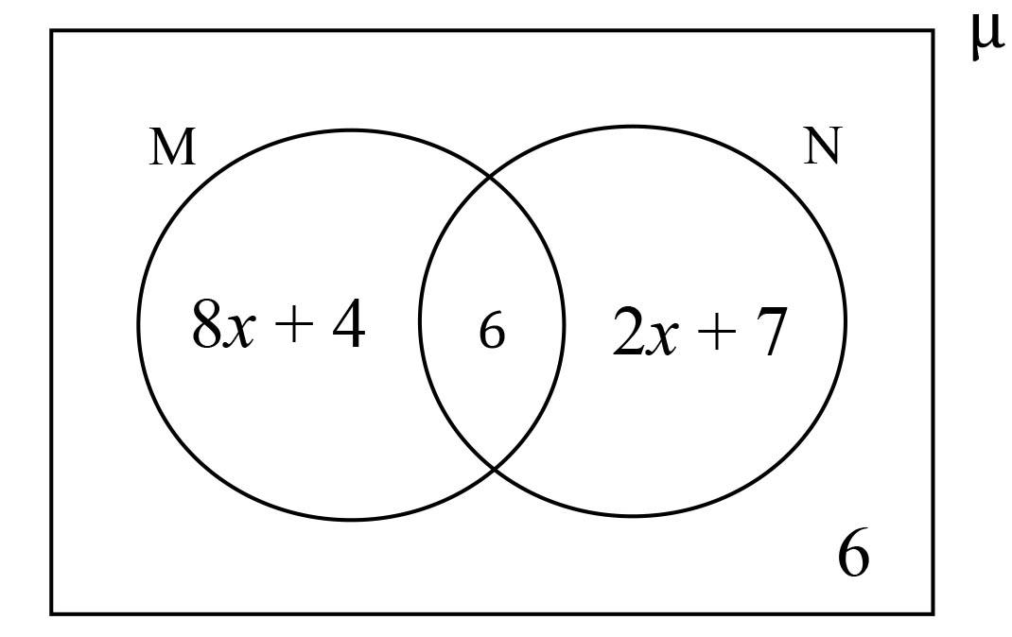
In the Venn diagram, M and N are intersecting sets in the universal set µ.
(a)

Express n(M) and n(N) in terms of x.
(b)

Given that n(M) = n(N), find the:
(i)

Value of x.
(ii)

n(µ)
(c)

Simplify: 2⁶ ÷ (2² x 2¹) ÷ 2⁵.

2.
(a)

Factorize the expression 5ay - by + 15a - 3b
(b)

Solve:

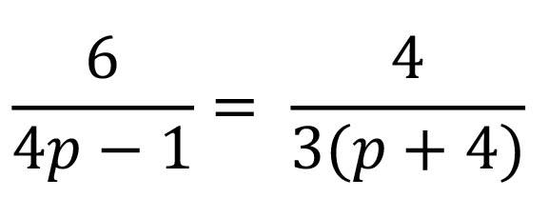

.
(c)

Esi and Kofi shared an amount of GH₵ 21,000.00 in the ratio of 2:5 respectively. How much more did Kofi receive than Esi?

3.
(a)

If r =

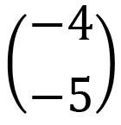

and m =

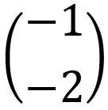

, find p given p = r - m.
(b)

The sum of two numbers is 81. If the second number is twice the first, find the second number
(c)

The floor of a rectangular hall is of length 9 m and width 4 m. How many tiles of 20 cm by 30 cm can be used to cover the floor completely.

4.
(a)

Antwiwaa bought 25 mangoes, 7 of which were unripe. What percentage of the mangoes were ripe?
(b)

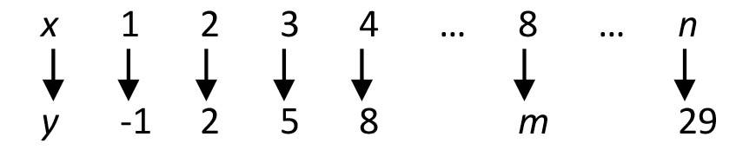
The mapping shows the relationship between x and y. Find the:
(i)

rule for the mapping;
(ii)

values of m and n
(c)

A bus left town X at 6:30 am and arrived at town Y at 1:00 pm. If the bus travelled at an average speed of 100 km per hour, calculate the distance from town X to town Y.

5.
(a)

Simplify: (4x + 2)(x - 2) - 3x²
(b)

The following are the angles formed at the center of a circle: 40º, 60º, 100º, 3xº and 5xº.
Find the value of x.
(c)

The cost (C) in Ghana Cedis of producing a book of x pages is given by C = 25 + 0.6x.
(i)

Find the cost of producing a book with 220 pages.
(ii)

How many pages are in a book produced at a cost of GH₵ 145.00?

6.
The table shows the number of marbles students sent to class for Mathematics lesson.
Number of Marbles(x) | Number of Students(f) | fx
1 | 4 | -
2 | 5 | -
3 | - | 42
4 | 9 | -
5 | - | 30
6 | 2 | 12
(a)

Copy and complete the table.
(b)

How many:
(i)

students were in the class?
(ii)

marbles were brought altogether
(iii)

marbles did most of the students bring
(c)

Calculate, correct to the nearest whole number, the mean number of the marbles brought for the lesson.

